Practical No : 17
Q.1] Write a React program to change the background color of a div when a button is clicked using the useState hook.

Code :-

import React, { useState } from "react";

function App() {
const [color, setColor] = useState("lightblue");

return (
<div
style={{
backgroundColor: color,
height: "200px",
textAlign: "center",
paddingTop: "50px",
}}
>
<button onClick={() => setColor("lightgreen")}>
Change Color
</button>
</div>
);
}

export default App;

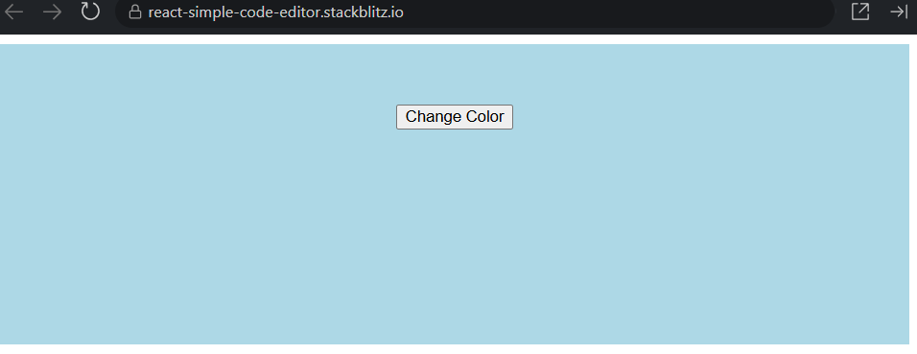

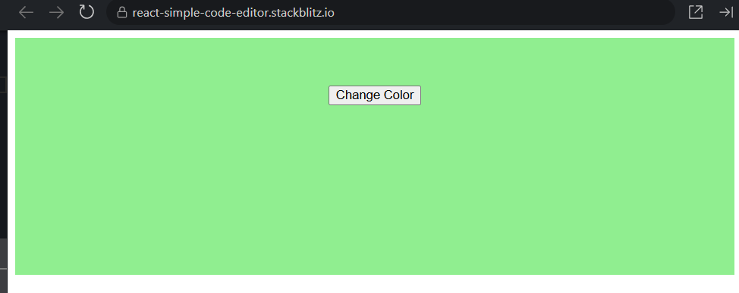

Q.2 Write a React program to manage user input using the useState hook.
import React, { useState } from "react";

function App() {
const [name, setName] = useState("");

return (
<div>
<input
type="text"
value={name}
onChange={(event) => setName(event.target.value)}
placeholder="Enter your name"
/>

<h2>Your Name: {name}</h2>
</div>
);
}

export default App;

